

**Software Design and Construction**

**Quiz Activity 2**

**Areeba Mahnoor BSSE23033**

**Shiza Shahbaz BSSE23089**

**Nauraiz Haider BSSE23047**

**Github repo link:**

**PHASE 1: Container Bootcamp**

**Challenge:**

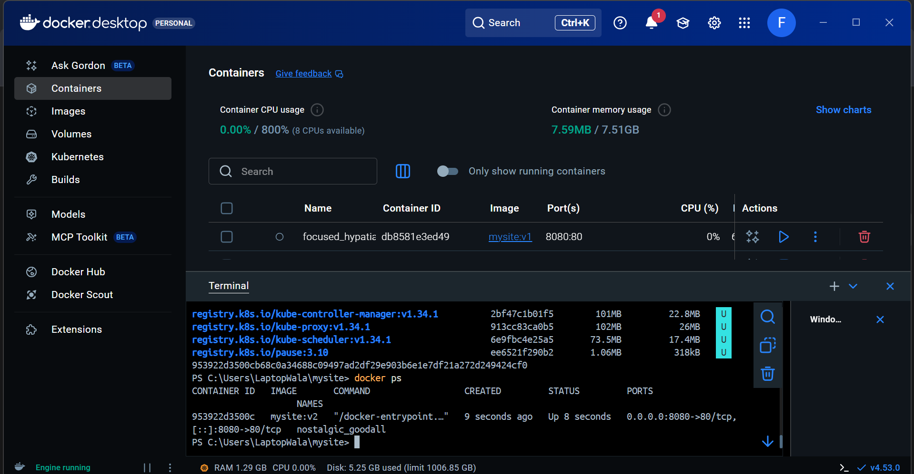

**PHASE 2: App to Containers (LAB 02)**

**PHASE 3: Multi-Service App (LAB 03)**

**DB logs**

**Stop service**

**Change db name and port**

**Logs of DB**

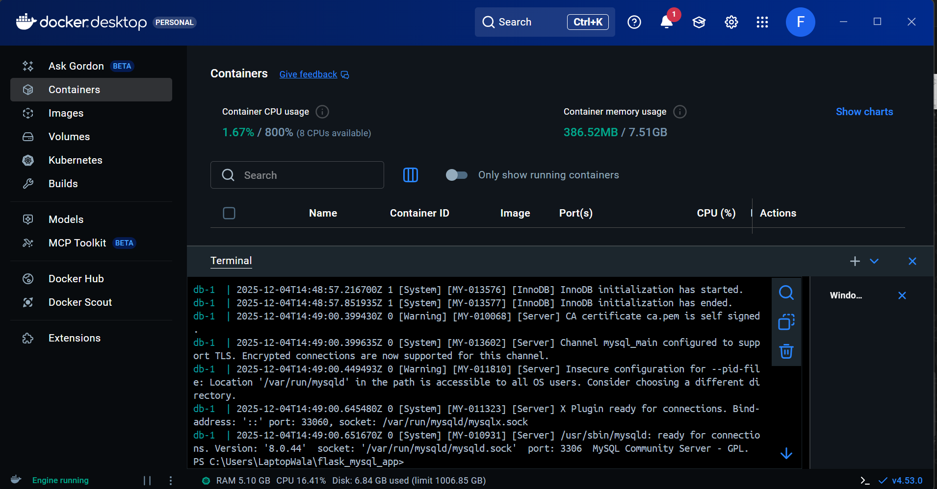

**Challenges:**

* **Add volume**

* **Restart only 1 service**

* **Kill backend then recover it**

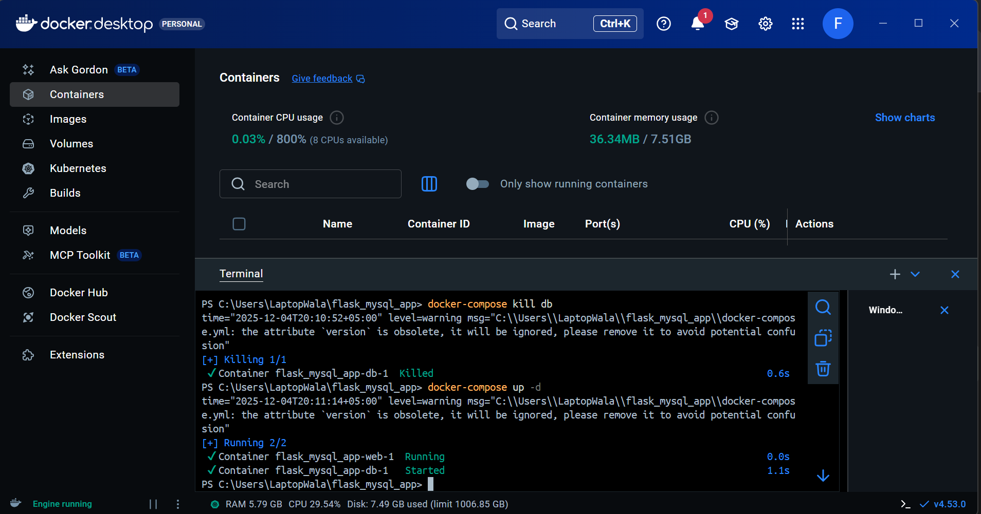

**Running containers**

**PHASE 4: CI/CD WAR ZONE (LAB 04)**

**Jenkins build and commit**

**Running pods**

